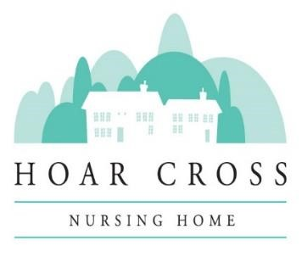
APPLICATION FOR EMPLOYMENT AT
HOAR CROSS NURSING HOME
All information will be treated as strictly confidential and no approach will be made to any person without your permission.
I ___________________________give consent for you to use the information I have provided in my application.
Position Applied for:__________________________________________________
If you obtained this position, would you continue in any other employment?
YES OR NO
Do we need to make any disability-related adjustments to allow you to take part in the recruitment process?
Personal Details
Title: | Forenames: | Surname:
Home Address:

Postcode:
Mobile Number: | Home Number: | Other:
Email address:
NI Number:
Qualified PIN if applicable:

Education & Training

School, college, etc: | Qualifications: | Date:
FULL Employment History (Continue on separate sheet if necessary)

Name of Employer: | Start & End Date: | Job Title: | Reason for Leaving:
Previous Relevant Experience
Interests

Driving Licence
Have you got a full UK Licence? YES/NO

Any current endorsements? YES/NO if yes, please give details

------------------------------------------------------------------------------------------------------------------
List any criminal convictions other than "spent" convictions. If none, state
"none"

The information provided will be confidential and will be considered only in relation to this application.
1st Employment Reference (must be your current or most recent employer)
Name:________________________________________
Company______________________________________
Address_________________________________________________________________
________________________________________________________________________
Telephone number:______________________________
Email Address:__________________________________

2nd Employment Reference
Name:_________________________________________
Company_______________________________________
Address_________________________________________________________________
________________________________________________________________________
Telephone number:______________________________

Email Address:__________________________________

Please detail any further information you wish to put forward in support of your application:

Vaccination
I confirm I have received both doses of the Covid Vaccination and have attached proof from my GP or via the NHS app.
Declaration
The above information is true. I understand that any job offer made based on untrue or misleading information may be withdrawn or my employment terminated.

Signature: Date:

